

AMERICAN INTERNATIONAL UNIVERSITY–BANGLADESH (AIUB)

Faculty of Science and Technology

Dept. of Computer Science

COURSE: SOFTWARE ENGINEERING

Spring 2025-2026

Section: C

Group No: 04

Software Requirement Specification [SRS] Document On

Smart Internship and Career Placement Portal

Supervised By:

MAHMUDUL HASAN

Submitted By

Name |  | ID
1. | MD SAKIB UDDIN | 23-53350-3
2. | MD SHIHAB ARMAN | 23-53398-3
3. | AFSA NUR SUBHANA | 23-53402-3
4. | SANZIDA AL-NOOR | 23-53403-3
5. | MST. HAWYA AKTER KEYA | 23-53652-3

Table of Contents

1. INTRODUCTION 3
2. SCOPES & FEATURES 4
2.1 Scope 1 4
2.2 Scope 2 4
2.3 Scope 3 4
3. USE CASE DIAGRAM 5
4. USER STORY TABLE 6
5. REQUIREMENT TRACEABILITY MATRIX 7
5.1 Functional Requirements 7
5.2 Non-Functional Requirements 7

INTRODUCTION

1.1 Background to the Problem / Problem Statement
The Smart Internship and Career Placement Portal is a web-based system designed to streamline the internship and job placement process for students, companies, and university authorities.
Currently, most universities rely on fragmented systems such as social media posts, emails, and notice boards to share internship and job opportunities. These traditional methods are inefficient, unorganized, and unreliable. Students often miss opportunities due to lack of centralized information, while companies struggle to find suitable candidates. Additionally, university authorities have limited control and monitoring capabilities over placement activities.
Previously built systems, if any, were either partially automated or lacked integration among stakeholders. These systems did not provide real-time updates, proper tracking, or structured workflows.
This project proposes a centralized, intelligent platform that integrates all stakeholders into one system. The novelty of this system lies in:
- Centralized job and internship management
- Real-time application tracking
- Role-based access for different users
- Integrated interview and feedback system
- Career guidance support
This system aims to eliminate inefficiencies, improve communication, and provide a structured and transparent placement process.

1.2 Selection of Process Model

1.2.1 Selected Process Model: Agile Development Model (Scrum-based Agile)
For the development of the Smart Internship and Career Placement Portal, the Agile Process Model is selected. Agile is an iterative and incremental software development model that focuses on flexibility, continuous feedback, and early delivery of functional software. The model allows requirements to evolve throughout the project lifecycle, making it highly suitable for web-based systems involving multiple stakeholders such as students, companies, university career officers, HR panels, and administrators.
1.2.2 Why Agile Model is Suitable for This Project
The Smart Internship and Career Placement Portal is a dynamic and user-centric system, and its requirements may change based on stakeholder feedback. Agile supports adaptability and continuous improvement, which is essential for this type of application.

Frequently Changing Requirements
Placement portals often evolve due to:
- New recruitment rules from universities
- Changes in company hiring processes
- Additional student profile or reporting requirements
Agile welcomes changing requirements even at later stages of development, ensuring the system remains relevant and effective.

Multiple User Roles and Stakeholders
The system serves:
- Students
- Companies / Recruiters
- University Career Officers
- HR / Interview Panels
- Admin
Each stakeholder has different expectations. Agile allows regular stakeholder interaction through reviews and feedback, ensuring that every role’s needs are properly addressed.

C) Modular Nature of the System
The portal consists of clearly defined modules:
- User Management
- Student Profile
- Job & Internship Management
- Application Tracking
- Interview Management
- Career Guidance
- Reporting and Analytics
Agile promotes incremental development, enabling these modules to be developed, tested, and delivered in separate iterations (sprints).

D) Early and Continuous User Feedback
Students and recruiters can test early versions of the portal and provide feedback on:
- UI/UX
- Application workflow
- Profile management
- Interview scheduling
This reduces rework and improves user satisfaction.

E) Faster Delivery of Working Software
Instead of waiting until the end of development, Agile ensures that working features are delivered early, such as:
- Login and registration
- Student profile creation
- Job posting and application system
This allows early validation of system functionality.

E) Risk Reduction
By implementing and testing features in short cycles, critical risks such as role-based access errors, data inconsistency, or poor usability can be detected and resolved early.

1.2.3 Details of the Agile Process Model
The Agile model divides the software development process into short, time-bound iterations called sprints. Each sprint results in a potentially deployable increment of the software.

Agile Development Phases Used in This Project
- Requirement Analysis
  - Gather functional and non-functional requirements from students, companies, and university authorities
  - Define user stories such as job application tracking, profile approval, interview scheduling, etc.
- Sprint Planning
  - Select a set of features (backlog items) to be implemented in the upcoming sprint
  - Prioritize essential modules like authentication and job posting first
- Design
  - Design user interfaces, system architecture, and database structure for selected features
  - Ensure role-based access control and security considerations
- Implementation
  - Develop frontend and backend features for the selected sprint
  - Example: Student profile module or job posting module
- Testing
  - Perform unit testing, integration testing, and functional testing
  - Verify that features work as per user stories and acceptance criteria
- Review and Feedback
  - Demonstrate the working features to stakeholders
  - Collect feedback and improvement suggestions
- Deployment
  - Deploy the updated version of the system
  - Make features accessible to users
- Next Sprint
  - Analyze feedback
  - Plan the next set of features

1.2.4 Figure: Agile Process Model

1.2.5 How the Agile Model Works for This Project
Agile Process Model is selected for the development of the Smart Internship and Career Placement Portal due to its flexibility and iterative nature. The system involves multiple stakeholders such as students, companies, career officers, and administrators, whose requirements may evolve during development. Agile supports incremental delivery, allowing core modules like user management, job posting, and application tracking to be developed and tested in short cycles. Continuous user feedback helps improve usability and functionality, while early and frequent testing reduces risks and errors. This makes Agile well suited for a dynamic, web-based placement system that requires continuous improvement and timely delivery of working features.

The Agile process model is the most suitable choice for the Smart Internship and Career Placement Portal because it supports flexibility, continuous improvement, early error detection, and frequent user involvement. Its iterative approach ensures that the system meets real-world needs while maintaining high quality and usability throughout the development lifecycle.

SCOPES & FEATURES
The scope of the Smart Internship and Career Placement Portal defines the major features and functionalities that will be developed to meet the system objectives. The system is divided into multiple scopes, each representing a logical group of features. Development is prioritized in phases, starting from core functionalities to advanced features.

Scope 1: Core User Management and Authentication (Highest Priority)
This scope covers the basic foundation of the system and will be developed first.

Features and Functionality
- User Registration and Login
  - Users (Student, Company, Career Officer, HR, Admin) can register and log in securely.
  - Authentication will be role-based to control access to features.
  - Password encryption and session management will be implemented.
- Role-Based Access Control
  - Each user role will have specific permissions.
  - Students cannot access admin or recruiter features.
  - Admin has full control of the system.
- Profile Management
  - Users can view and update their basic information.
  - Students can upload resumes and academic details.
  - Companies can manage organizational profiles.

How It Works
- A user registers and logs in.
- The system identifies the role and redirects to the appropriate dashboard.
- Permissions are enforced throughout the system.
Reason for Priority: Without authentication and role management, other modules cannot function.

Scope 2: Student and Opportunity Management (High Priority)
This scope focuses on student activities and opportunity listings.

Features and Functionality
- Student Profile Module
  - Students create complete profiles including education, skills, and CV.
  - Profiles can be updated anytime.
  - Career officers can review and approve profiles.
- Job and Internship Posting
  - Companies can post job and internship opportunities.
  - Posts include role, qualifications, deadline, and location.
  - Admin approval may be required before posts go live.
- Search and Filter Functionality
  - Students can search jobs and internships based on keywords, skills, and location.
  - Filters improve ease of use.

How It Works
- Companies post opportunities.
- Students browse and search suitable roles.
- Approved jobs are visible to eligible students.
Reason for Priority: This scope directly supports the core objective—connecting students with opportunities.

Scope 3: Application and Interview Management (Medium Priority)
This scope manages the recruitment workflow.

Features and Functionality
- Application Management
  - Students can apply for jobs and internships.
  - Application status (Applied, Shortlisted, Rejected, Selected) is visible.
  - Companies can review and manage applications.
- Interview Scheduling
  - Recruiters/HR can schedule interviews.
  - Students receive notifications.
  - Interview results can be updated after completion.
- Feedback System
  - HR can provide interview feedback.
  - Career officers can use feedback for guidance.

How It Works
- A student submits an application, which is then reviewed by the recruiter, followed by interview scheduling and final result updates.
- Status changes are automatically reflected in the student dashboard.
Reason for Priority: This scope completes the recruitment lifecycle after opportunity discovery.

Scope 4: Career Guidance, Monitoring, and Reporting (Lower Priority)
This scope enhances the system with analytics and support features.

Features and Functionality
- Career Guidance Module
  - Career officers share training materials, workshops, and guidance.
  - Students can access career resources.
- Monitoring and Analytics
  - Admin monitors system usage and placement statistics.
  - Career officers track student placement progress.
- Report Generation
  - Reports on placements, applications, companies, and users.
  - Useful for institutional records and decision-making.

How It Works
- Data is collected from system activities.
- Reports are generated automatically.
- Authority users analyze placement performance.
Reason for Priority: These features are supportive and depend on core modules.

Development Priority Summary (Serial Order)
- User Registration & Login
- Role-Based Access Control
- User Profile Management
- Student Profile Creation
- Job & Internship Posting
- Job Search & Filtering
- Application Submission & Tracking
- Interview Scheduling & Feedback
- Career Guidance Module
- Reports & Analytics
The project scope is structured into prioritized phases to ensure systematic development. Core functionalities are implemented first to establish system stability, followed by recruitment workflow management and advanced analytical features. This approach ensures timely delivery, better testing, and scalability.

USE CASE DIAGRAM
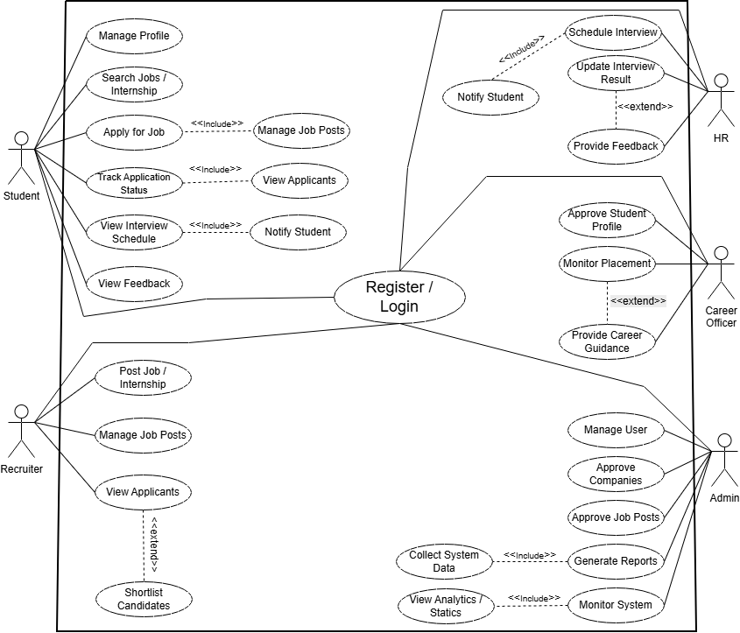

USER STORY TABLE

FUNCTIONAL REQUIREMENTS
Module | Screen Definition | User Story | Acceptance Criteria
Sign Up | Name, Email, Password, Role selection, Register button | As a new user, I want to register so that I can access the portal. | Mandatory fields must be filled; email must be unique; password must meet security rules; successful registration confirmation shown.
Login | Email, Password, Login button | As a registered user, I want to log in so that I can use system features. | Valid credentials required; error shown for invalid login; user redirected to role-based dashboard.
Student Profile | Personal info, academic details, skills, CV upload | As a student, I want to create and update my profile so that recruiters can evaluate me. | All required fields validated; CV upload supported; profile saved successfully.
Job / Internship Posting | Job title, description, eligibility, deadline, location | As a company, I want to post jobs and internships so that students can apply. | Mandatory details required; post visible after admin approval; confirmation message displayed.
Job Search | Search bar, filters, job list | As a student, I want to search opportunities so that I can find suitable jobs or internships. | Search results must be relevant; filters work correctly; job details displayed clearly.
Application Management | Apply button, application status | As a student, I want to apply and track applications so that I know my progress. | Application submitted successfully; duplicate applications prevented; status updated correctly.
Recruiter Dashboard | Applicant list, shortlist option | As a recruiter, I want to review applications so that I can shortlist candidates. | Only authorized recruiters can access; shortlist action updates status successfully.
Interview Management | Schedule interview, update result | As an HR member, I want to manage interviews so that selection is organized. | Interview schedule saved; students notified; results updated correctly.
Career Officer Module | Student monitoring, guidance resources | As a career officer, I want to monitor placements so that I can guide students. | Student data visible; guidance content accessible; placement status accurate.
Admin Dashboard | User management, approvals, reports | As an admin, I want to manage the system so that it runs smoothly. | Can approve users and postings; reports generated correctly; admin-only access enforced.

NON-FUNCTIONAL REQUIREMENTS
Module | Screen Definition | User Story | Acceptance Criteria
System Performance | — | As a stakeholder, I want the system to be fast so that users do not face delays. | Page response time ≤ 2 seconds; system handles multiple users efficiently.
Security | — | As a stakeholder, I want secure authentication so that user data is protected. | Passwords encrypted; role-based access enforced; unauthorized access blocked.
Usability | — | As a user, I want an easy-to-use interface so that I can navigate effortlessly. | Interface is intuitive; error messages clear; consistent UI across modules.
Reliability | — | As a stakeholder, I want the system to be reliable so that it works without failure. | System uptime ≥ 99%; proper error handling; data not lost on failure.
Scalability | — | As an administrator, I want the system to scale so that more users can be supported. | System supports increasing users without performance degradation.
Data Integrity | — | As a stakeholder, I want accurate data so that decisions are reliable. | No duplicate or inconsistent records; validated data storage.

REQUIREMENT TRACEABILITY MATRIX

But in this section a table need to be created containing the requirements, which requirement is developed in which code file. Status about the test case. For functional and non functional two different table need to be created. Example given. Initialize the first three column, rest we will do it later.

Req ID | Requirement Description | Design Module | Code Module | Test Case ID | Status
R1 | User login system | Auth Design | login.py | TC01 | Pass
R2 | Password reset | Auth Design | reset.py | TC02 | Pass
R3 | View profile | User Module | profile.py | TC03 | Fail
R4 | Generate report | Report Module | report.py | TC04 | Pass

Functional Requirements
- The system shall allow users (Student, Company, Career Officer, HR, Admin) to register and log in securely.
- The system shall provide role-based access control and dashboards for different users.
- The system shall allow students to create, update, and manage their profiles, including CV upload.
- The system shall allow companies to post job and internship opportunities.
- The system shall allow students to search, filter, and view job and internship listings.
- The system shall allow students to apply for jobs and internships online.
- The system shall allow recruiters to view, shortlist, and manage student applications.
- The system shall allow HR to schedule interviews and update interview results.
- The system shall allow career officers to monitor placement activities and provide guidance.
- The system shall allow administrators to manage users, approve postings, and generate reports

Non-Functional Requirements
- Performance: The system shall respond to user requests within an acceptable time (≤ 2 seconds).
- Security: The system shall ensure secure authentication, encrypted passwords, and role-based authorization.
- Usability: The system shall have an intuitive and user-friendly interface.
- Reliability: The system shall be available with minimal downtime and handle errors gracefully.
- Scalability: The system shall support an increasing number of users without performance degradation.
- Data Integrity: The system shall maintain accurate, consistent, and non-duplicated data.
- Accessibility: The system shall be web-based and accessible from different devices and browsers

